**DAILY ONLINE ACTIVITIES SUMMARY**

|  |  |  |  |  |  |  |  |  |
| --- | --- | --- | --- | --- | --- | --- | --- | --- |
| **Date:** | **13/08/2020** | | | | | **Name:** | **Spoorthy Balaji** | |
| **Sem & Sec** | **6th & B** | | | | | **USN:** | **4al17cs098** | |
| **Online Test Summary** | | | | | | | | |
| **Subject** | | **-** | | | | | | |
| **Max. Marks** | | **-** | | **Score** | | | **-** | |
| **Certification Course Summary** | | | | | | | | |
| **Course** | Introduction to Cybersecurity Tools & Cyber Attacks | | | | | | | |
| **Certificate Provider** | | | **Coursera** | | **Duration** | | | **4Weeks** |
| **Coding Challenges** | | | | | | | | |
| **Problem Statement: Python Program for Legendre\’s Conjecture** | | | | | | | | |
| **Status: Solved** | | | | | | | | |
| **Uploaded the report in Github** | | | | | **yes** | | | |
| **If yes Repository name** | | | | | <https://github.com/spoorthybalaji/Daily_Status> | | | |
| **Uploaded the report in slack** | | | | | **yes** | | | |

**ONLINE COURSE**

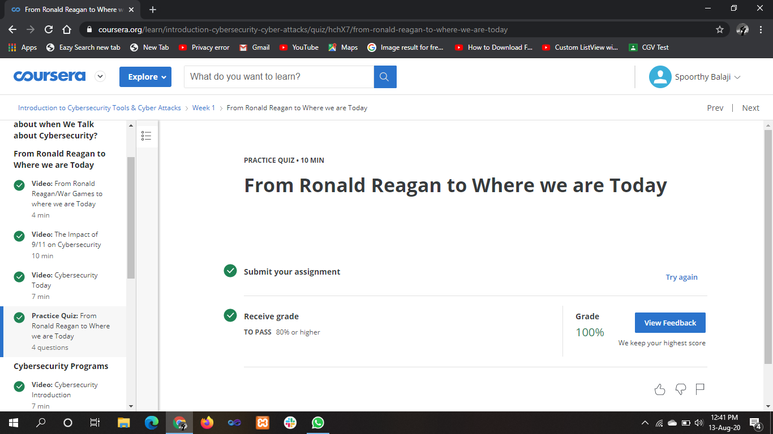

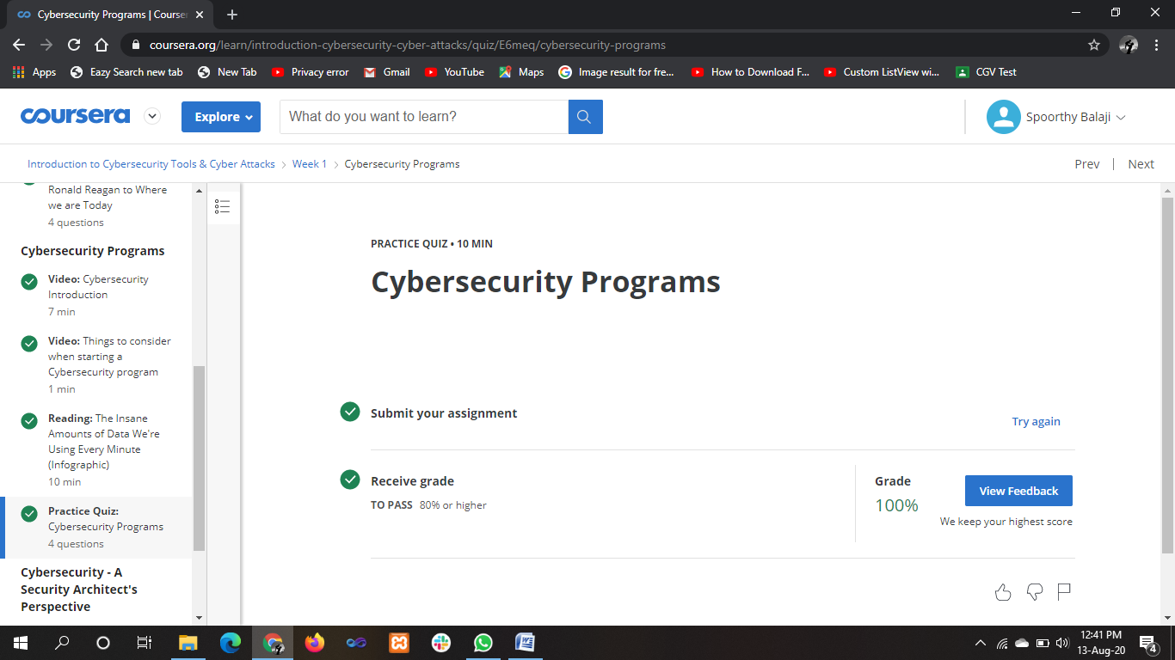

**ONLINE** **CODING**

**Python Program for Legendre\’s Conjecture**

import math

def isprime( n ):

i = 2

for i in range (2, int((math.sqrt(n)+1))):

if n%i == 0:

return False

return True

def LegendreConjecture( n ):

print ( "Primes in the range ", n*n , " and ", (n+1)*(n+1) , " are:" )

for i in range (n*n, (((n+1)*(n+1))+1)):

if(isprime(i)):

print (i)

n = 50

LegendreConjecture(n)

